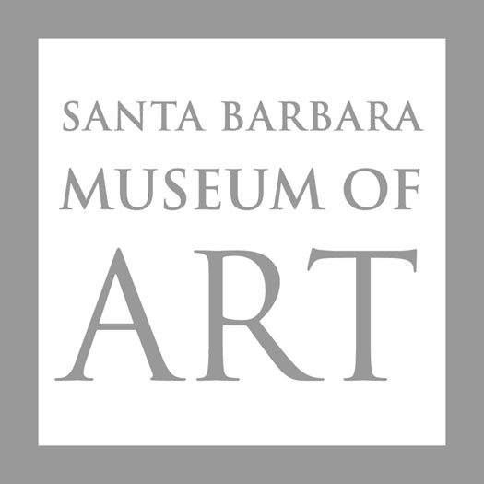

DECLARATION OF INTENT
I am pleased to play a role to assure that future generations will enjoy the rich educational opportunities and treasures of the Santa Barbara Museum of Art. For this reason, I have named SBMA as a beneficiary of my estate through a:
□ Bequest □ Charitable Remainder Trust □ Life Insurance Policy
□ Retirement Plan □ Other______________________________________________
In signing this document, I declare that I have made a provision in my Estate Plan to support the Santa Barbara Museum of Art in perpetuity as indicated above.
Signature_______________________________________ Date_________________________

______ I have not yet included SBMA in my estate plan, however, please contact me to discuss how planned giving can benefit me, the Museum and the community.
Please Print:
Name___________________________________________ Date of Birth_________________
Name of Spouse: __________________________________ Date of Birth_________________
Address:_____________________________________________________________________
City:_____________________________ State:_____________________ Zip: _____________
Telephone: ___________________________________________________________________
Primary Email: ________________________________________________________________
Please keep a copy of this form for your files.
Also provide a copy to your estate planning professional for safekeeping
and return the original to:

Karen Kawaguchi, Director of External Affairs
Santa Barbara Museum of Art
1130 State Street, Santa Barbara, CA 93101-2746
www.sbma.net
Federal Tax ID # 95-1664122

For more information, please call (805) 884-6431 or email kkawaguchi@sbma.net

